**High Commission of India**

**Brunei Darussalam**

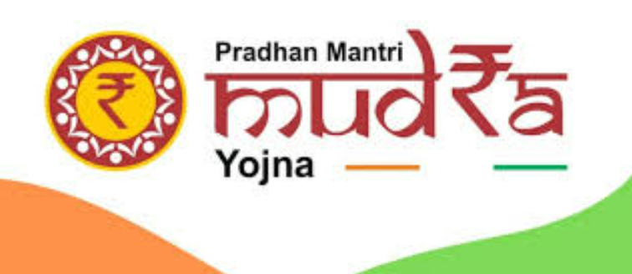

**The Pradhan Mantri Mudra Yojana (PMMY) has reached a remarkable milestone, completing 10 years since its inception in April 2015. This flagship initiative, launched by the Government of India, has been a cornerstone in fostering financial inclusion and empowering small entrepreneurs across the nation.**

**Over the past decade, PMMY has sanctioned more than 52 crore loans, amounting to over ₹33 lakh crore. The scheme has been instrumental in providing collateral-free loans to non-corporate, non-farm small and micro enterprises, enabling them to thrive and contribute to the economy. Categorized into Shishu, Kishore, and Tarun, the loans cater to businesses at different stages of growth, ensuring comprehensive support.**

**One of the most commendable aspects of PMMY is its focus on inclusivity. Nearly 70% of the loans have been availed by women entrepreneurs, while 50% of the beneficiaries belong to SC, ST, and OBC communities. This has not only uplifted marginalized sections but also fostered social and economic empowerment.**

**The scheme's impact extends beyond financial assistance. It has generated over 1 crore jobs in its initial years and continues to drive entrepreneurship and innovation. States like Bihar have emerged as leaders, showcasing a robust entrepreneurial spirit.**

**As PMMY celebrates a decade of success, it stands as a testament to the transformative power of inclusive policies. It has turned countless dreams into reality, proving that with the right support, India's entrepreneurial potential knows no bounds.**